## INTERNSHIP REPORT

## ON

**WEB DEVELOPMENT**

submitted in partial fulfilment of the requirements for the award of the degree

of

# BACHELOR OF TECHNOLOGY

in

# CSE - ARTIFICIAL INTELLIGENCE &

# MACHINE LEARNING



**By**

## M Lakshmikanth 20751A3334

**SREENIVASA INSTITUTE OF TECHNOLOGY AND MANAGEMENT STUDIES, CHITTOOR-517127, A.P.**

**(Autonomous)**

**(Approved by AICTE & Affiliated to JNTUA, Ananthapuramu)**

**DEPARTMENT OF CSE- ARTIFICIAL INTELLIGENCE**

**& MACHINE LEARNING**

**(2023-24)**

**SREENIVASA INSTITUTE OF TECHNOLOGY AND MANAGEMENT STUDIES, CHITTOOR-517127, A.P.**

**(Autonomous-NBA Accredited)**

**(Approved by AICTE & Affiliated to JNTUA, Ananthapuramu)**



**BONAFIDE CERTIFICATE**

This is to certify that the internship report “**Web Development”** is a genuine work of

## M Lakshmi kanth 20751A3334

Submitted to the department of CSE-(Artificial intelligence and Machine Learning), in fulfilment of the requirements for the award of the degree of Bachelor of Technology in CSE-(AI&ML) during the academic year 2023-2024.

|  |  |
| --- | --- |
| Signature of the Supervisor | Signature of the Head of Department |
| **Mr V Raghubathy,**  Assistant Professor  Department of CSE-(AI&ML)  Sreenivasa Institute of Technology and  Management Studies, Chittoor, A.P. | **Dr. M. ARTHI**  Professor & HOD,  Department of CSE-(AI&ML)  Sreenivasa Institute of Technology and  Management Studies, Chittoor, A.P. |

Submitted for University Examination(viva-voice) held on…………….

INTERNAL EXAMINER EXTERNAL EXAMINER

# INTERNSHIP CERTIFICATE

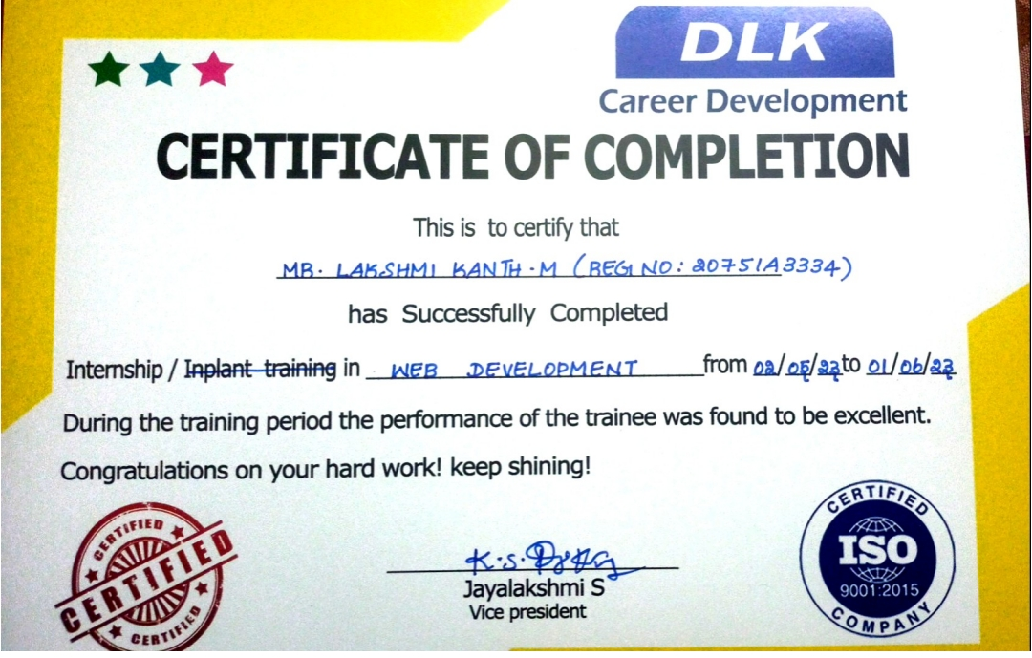

**DECLARATION**

I hereby declare that the Internship Report entitled **“Web Development”** which is being submitted to the **SREENIVASA INSTITUTE OF TECHNOLOGY AND MANAGEMENT STUDIES, CHITTOOR** for the award of Bachelor of Technology in **CSE-Artificial intelligence and Machine Learning** is a bonafide report of the work carried out by me. The material contained in this internship Work Report has not been submitted to any University of Institution for the award of any degree.

M Lakshmi kanth 20751A3334

**ACKNOWLEDGEMENT**

Any achievement, be it scholastic or otherwise does not depend solely on the individual effort but on the guidance, encouragement and cooperation of intellectuals, elders, and friends. We would like to take this opportunity to thank them all.

We feel ourselves honored for placing our warm salutation to THE MANAGEMENT, SITAMS, which gave us the opportunity to obtain a strong base in Tech and profound knowledge.

We would like to express the heartfelt gratitude to our Management, Chairman Sri. K Ranganatham Garu for providing excellent institutional support to complete this project.

We express our sincere thanks to Dr. N Venkatachalapathi, M.Tech., Ph.D., our beloved Principal for his encouragement and suggestions during our course of study.

With deep sense of gratitude, we acknowledge Dr. M Arthi, B.E., M.E., Ph.D., Head of the Dept., Artificial Intelligence & Machine Learning, for her valuable support and help in processing our Project.

We also express thanks to our Project Coordinator, Mr. V Raghubathy, Assistant Professor in Department of Artificial Intelligence & Machine Learning for encouraging us in doing this Project.

Finally, we would like to express our sincere thanks to all the Faculty Members of CSM Department, and Lab Technicians, Friends & Family members, who all have motivated and helped us to do this project.

M Lakshmi kanth 20751A3334

# SREENIVASA INSTITUTE OF TECHNOLOGY AND MANAGEMENT STUDIES

**(Autonomous)**

# Institute Vision

To emerge as a Centre of Excellence for Learning and Research in the domains of engineering, computing and management.

# Institute Mission

* Provide congenial academic ambience with state-art of resources for learning and research.
* Ignite the students to acquire self-reliance in the latest technologies.
* Unleash and encourage the innate potential and creativity of students.
* Inculcate confidence to face and experience new challenges.
* Foster enterprising spirit among students.
* Work collaboratively with technical Institutes / Universities / Industries of National and International repute

# DEPARTMENT OF COMPUTER SCIENCE AND ENGINEERING

**VISION**

To contribute for the society through excellence in Computer Science and Engineering (Artificial Intelligence and Machine Learning) with a deep passion for wisdom, culture and values.

# MISSION

**M 1:** Provide congenial academic ambience with necessary infrastructure and learning resources.

**M 2:** Inculcate confidence to face and experience new challenges from industry and society.

**M 3:** Ignite the students to acquire self-reliance in State-of-the-Art Technologies **M 4:** Foster Enterprising spirit among students.

# PROGRAMME EDUCATIONAL OBJECTIVES (PEOs):

After few years of graduation the, graduates of Computer Science and Engineering (Artificial Intelligence and Machine Learning) shall

**PEO1:** Expertise with computer science and Engineering, artificial intelligence and machine learning disciplines through quality studies, enabling success in IT industries. (Professional Competency) **PEO2:** Establish start-up companies or employed in reputed computing industries or government sectors or pursue higher studies in the domain of CSE (AI & ML) (Successful Career Goals)

**PEO3:** Enhance knowledge by updating advanced technological concept for facing the rapidly changing world and contribute to society through innovations and creativity. (Continuing Education and Contribution to Society)

# PROGRAM SPECIFIC OUTCOMES (PSO's):

Students Shall

**PSO1:** Demonstrate and analyse the mathematical methodologies to develop computer programs using networking, web design, big data analytics, machine learning algorithms, data science, neural networks and deep learning techniques.

**PSO2:** Deploy the artificial intelligence techniques to perform human intelligence in creating innovative products and solutions.

# PROGRAMME OUTCOMES (PO’s)

Computer Science and Engineering (Artificial Intelligence and Machine Learning) will be able to: **PO1** - **Engineering knowledge:** Apply the knowledge of mathematics, science, engineering fundamentals, and an engineering specialization for the solution of complex engineering problems. **PO2** - **Problem analysis:** Identify, formulate, research literature, and analyze complex engineering problems reaching substantiated conclusions using first principles of mathematics, natural sciences, and engineering sciences.

**PO3 - Design/development of solutions:** Design solutions for complex engineering problems and design system components or processes that meet the specified needs with appropriate consideration for public health and safety, and cultural, societal, and environmental considerations. **PO4 - Conduct investigations of complex problems:** Use research-based knowledge and research methods including design of experiments, analysis and interpretation of data, and synthesis of the information to provide valid conclusions.

**PO5 - Modern tool usage:** Ability to design and develop hardware and software in emerging technology environments like cloud computing embedded products, real-time systems, Internet of Things, Big Data etc.

**PO6- Engineering and Society:** Apply reasoning informed by the contextual knowledge to assess societal, health, safety, legal and cultural issues and the consequent responsibilities relevant to the professional engineering practice.

**PO7- Environment and sustainability:** Understand the impact of the professional engineering solutions in societal and environmental contexts, and demonstrate the knowledge of, and need for sustainable development.

**PO8- Ethics:** Apply ethical principles and commit to professional ethics and responsibilities and norms of the engineering practice.

**PO9 - Individual and team work:** Function effectively as an individual, and as a member or leader in diverse teams, and in multidisciplinary settings.

**PO10 - Communication:** Communicate effectively on complex engineering activities with the engineering community and with the society at large, such as, being able to comprehend and write effective reports and design documentation, make effective presentations, and give and receive clear instructions.

**PO11 - Project management and finance:** Demonstrate knowledge and understanding of the engineering and management principles and apply these to one’s own work, as a member and leader in a team, to manage projects and in multidisciplinary environments.

**PO12 - Life-long learning:** Basic knowledge in hardware/software methods and tools for solving real-life and R&D problems with an orientation to lifelong learning.

# Course Outcomes for project work

On completion of project work we will be able to,

**CO1.** Demonstrate in-depth knowledge on the project topic.

**CO2.** Identify, analyze and formulate complex problem chosen for project work to attain substantiated conclusions.

**CO3.** Design solutions to the chosen project problem.

**CO4.** Undertake investigation of project problem to provide valid conclusions.

**CO5.** Use the appropriate techniques, resources and modern engineering tools necessary for project work.

**CO6.** Apply project results for sustainable development of the society.

**CO7.** Understand the impact of project results in the context of environmental sustainability. **CO8.** Understand professional and ethical responsibilities while executing the project work. **CO9.** Function effectively as individual and a member in the project team.

**CO10.** Develop communication skills, both oral and written for preparing and presenting project report.

**CO11.** Demonstrate knowledge and understanding of cost and time analysis required for carrying out the project.

**CO12.** Engage in lifelong learning to improve knowledge and competence in the chosen area of the project.

CO – PO MAPPING

|  |  |  |  |  |  |  |  |  |  |  |  |  |
| --- | --- | --- | --- | --- | --- | --- | --- | --- | --- | --- | --- | --- |
| **COs \ POs** |  |  |  |  |  |  |  |  |  |  |  |  |
| **CO1** | √ |  |  |  |  |  |  |  |  |  |  |  |
| **CO2** |  | √ |  |  |  |  |  |  |  |  |  |  |
| **CO3** |  |  | √ |  |  |  |  |  |  |  |  |  |
| **CO4** |  |  |  | √ |  |  |  |  |  |  |  |  |
| **CO5** |  |  |  |  | √ |  |  |  |  |  |  |  |
| **CO6** |  |  |  |  |  | √ |  |  |  |  |  |  |
| **CO7** |  |  |  |  |  |  | √ |  |  |  |  |  |
| **CO8** |  |  |  |  |  |  |  | √ |  |  |  |  |
| **CO9** |  |  |  |  |  |  |  |  | √ |  |  |  |
| **CO10** |  |  |  |  |  |  |  |  |  | √ |  |  |
| **CO11** |  |  |  |  |  |  |  |  |  |  | √ |  |
| **CO12** |  |  |  |  |  |  |  |  |  |  |  | √ |

**ABSTRACT**

presents an in-depth exploration of web development focusing on HTML, CSS, and JavaScript – the fundamental building blocks that underpin the creation of modern web applications and websites. It delves into the individual roles of these core technologies, their synergistic relationship, and their collective impact on shaping the online user experience.The report commences with an overview of HTML (HyperText Markup Language) as the foundational language for structuring web content. It discusses the evolution of HTML, its various versions, and the critical role it plays in defining the elements, layout, and semantic structure of web pages.Subsequently, the report delves into CSS (Cascading Style Sheets) and its significance in web development. It elucidates how CSS complements HTML by controlling the presentation, layout, and visual aesthetics of web pages. The evolution of CSS from its basic styling features to its modern capabilities, including HTML and CSS frameworks, is also explored.Furthermore, the report extensively examines JavaScript, a powerful scripting language essential for adding interactivity, dynamic behavior, and functionality to web pages. It outlines JavaScript's evolution, its diverse ecosystem of libraries and frameworks (such as javacscript,sql and JDBC), and its pivotal role in enabling client-side and server-side scripting.The report emphasizes the symbiotic relationship between HTML, CSS, and JavaScript, showcasing their integration to create responsive, visually appealing, and interactive web experiences. It elucidates the importance of responsive web design principles, accessibility considerations, and performance optimization techniques that leverage these technologies for an enhanced user experience across various devices and platforms.Moreover, the report highlights best practices, common challenges, and recommended approaches when utilizing HTML, CSS, and JavaScript in web development projects. It addresses security concerns, browser compatibility issues, and the significance of adhering to web standards to ensure cross-platform compatibility and usability.

|  |  |  |
| --- | --- | --- |
| **Chapter no** | **Table of Contents** | **Page no** |
|  | **Abstract** | vi |
|  | **List of figures** | viii |
| **Chapter 1** | **INTRODUCTION** |  |
|  | 1.1 Evolution of web development | 1-2 |
|  | 1.2 Frontend | 2-3 |
|  | 1.3 Backend | 3-5 |
| **Chapter 2** | **TOOLS USED** |  |
|  | 2.1 Net beans | 6-7 |
|  | 2.2 VScode | 7-8 |
|  | 2.3 Yog sql | 9-10 |
| **Chapter 3** | **LANGUAGE USED** |  |
|  | 3.1 Html | 11-12 |
|  | 3.2 CSS | 12-13 |
|  | 3.2 Java script & Core java | 13-15 |
|  | 3.4 SQL | 15-16 |
| **Chapter 4** | **WEB DEVELOPMENT** |  |
|  | 4.1 Idea of webpage | 17-21 |
| **Chapter 5** | **OUTPUTS AND RESULTS** | 22-25 |
|  | **CONCLUSION AND FUTURE ENHANCEMENT** | 26 |
|  | **REFRENCES** | 27 |
|  | **APPENDEX** | 28-33 |

**LIST OF FIGURES**

|  |  |  |
| --- | --- | --- |
| **Fig. No.** | **Title** | **Page No.** |
| 2.1  2.2  2.3  5.1  5.2  5.3  5.4  5.5  5.6  5.7  5.8 | Net beans  VScode  SQL yog  Main page  Showcase  Staff details  Registration page  Social media link  Contact  HOD details  About the club | 7  9  10  22  22  23  23  24  24  25  25 |

**CHAPTER 1**

**INTRODUCTION**

**1.1 Evolution of web development**

The evolution of web development has been a dynamic and ongoing process since the inception of the World Wide Web in the early 1990s. Over the years, numerous technologies, standards, and methodologies have emerged, transforming the way websites and web applications are built and experienced. Here's an overview of the key stages in the evolution of web development:

HTML and Static Websites (1990s)Tim Berners-Lee created the first web browser and server in 1990. HTML (Hypertext Markup Language) was introduced as the foundational language for creating static web pages. Websites were basic and consisted mainly of text, hyperlinks, and images.

Introduction of CSS (Cascading Style Sheets) CSS emerged in the late 1990s, allowing developers to separate content from presentation. It brought significant improvements in website design by providing better control over layout, fonts, colors, and styles.

Dynamic Content and JavaScript (Late 1990s - Early 2000s) JavaScript was introduced, enabling developers to create dynamic and interactive elements on web pages. Technologies like AJAX (Asynchronous JavaScript and XML) allowed for smoother and faster data exchange between the browser and server without reloading the entire page.

Content Management Systems (CMS):Platforms like WordPress, Joomla, and Drupal gained popularity in the mid-2000s, enabling easier website creation and management through pre-built templates and content management systems.

Rise of Web Frameworks and Libraries (Mid-2000s - Present) Frameworks like Ruby on Rails, Django, and AngularJS (later Angular) provided efficient structures and tools for building web applications. Libraries such as jQuery simplified JavaScript coding and DOM manipulation.

Mobile Responsive Design (2010s - Present) The proliferation of smartphones led to the need for mobile-friendly websites. Responsive web design became essential, allowing websites to adapt and function seamlessly across various devices and screen sizes.

Advancements in Frontend Technologies: Introduction of modern frontend frameworks/libraries like React, Vue.js, and Angular, utilizing virtual DOM, component-based architecture, and reactive programming for efficient and scalable web application development.

Server-side Technologies and APIs: Node.js, along with advancements in server-side technologies, facilitated the development of fast and scalable server-side applications. RESTful and GraphQL APIs revolutionized data exchange between the client and server.

Progressive Web Apps (PWAs) PWAs emerged as a blend of web and mobile apps, offering app-like experiences with offline capabilities, push notifications, and improved performance.WebAssembly (Wasm) and Web APIs The introduction of WebAssembly allowed running complex applications written in languages like C/C++ directly in the browser, expanding the capabilities of web applications. Web APIs like WebRTC, WebSockets, and WebGPU further enhanced functionality and real-time communication.

The evolution of web development continues, with a focus on performance optimization, accessibility, security, and the integration of new technologies to create richer and more engaging web experiences.

**1.2 Frontend**

Web frontend design refers to the process of creating the user interface (UI) and user experience (UX) for websites or web applications. It involves designing the visual elements, layout, and interactions that users encounter and interact with on the client side (in the browser). Here's an explanation of key components and considerations in web frontend design:

UI/UX Design:User Interface (UI) design focuses on the look and feel of the website, including elements like colors, typography, icons, buttons, and overall aesthetics. User Experience (UX) design deals with the overall user journey, ensuring ease of navigation, intuitive interaction,

HTML (Hypertext Markup Language)HTML provides the structure and content of a web page. It defines the elements on the page, such as headings, paragraphs, images, links, forms, etc.

CSS (Cascading Style Sheets)CSS is used for styling and presentation. It allows designers and developers to control the layout, appearance, and design of HTML elements. CSS can specify colors, fonts, spacing, responsiveness, and other visual aspects of the webpage.Responsive Design With the prevalence of various devices (desktops, tablets, smartphones), responsive design ensures that web pages adapt and display properly across different screen sizes and devices. This is achieved through fluid grids, flexible images, and media queries.

JavaScript and Frontend Frameworks/Libraries: JavaScript is a programming language used for adding interactivity and dynamic behavior to web pages. Frontend frameworks/libraries like React, Vue.js, and Angular provide reusable components, state management, and efficient ways to build complex user interfaces.

Accessibility Designing for accessibility ensures that the website is usable by people of all abilities. It involves considering factors like screen readers, keyboard navigation, contrast ratios, and providing alternative text for images.

Prototyping and Wireframing Designers often create wireframes or prototypes to plan and visualize the layout, flow, and functionality of a website before the actual development. Tools like Figma, Adobe XD, Sketch, or wireframing tools aid in this process.

Performance Optimization Optimizing frontend performance involves techniques such as minification of files, lazy loading images, using content delivery networks (CDNs), and reducing render-blocking resources to enhance page loading speed and user experience Animation and Interaction Thoughtful use of animations and interactive elements can enhance user engagement.

Web frontend design is an evolving field that requires a balance between aesthetics, functionality, and usability to create compelling and user-friendly web experiences.

**1.3 Backend**

Backend development in web development refers to the server-side of applications, where data is processed, stored, and managed. It deals with the logic, database interactions, server configuration, and other functionalities that enable the frontend (client-side) of a website or web application to function properly. Here are key aspects and technologies related to backend web development:Server-Side Languages Backend development involves using programming languages like Python, JavaScript (Node.js), Ruby, PHP, Java, C#, and others to create the logic and functionality of the application.

Frameworks and Libraries Backend frameworks like Express.js (for Node.js), Django (for Python), Ruby on Rails, Laravel (for PHP), Spring (for Java), etc., provide pre-built structures and tools to streamline backend development.

Databases Backend developers work with databases to store and manage application data. This includes relational databases like MySQL, PostgreSQL, SQLite, as well as NoSQL databases like MongoDB, Redis, Cassandra, etc.

APIs (Application Programming Interfaces) Backend developers create APIs that allow communication between the frontend and backend, enabling data exchange and interactions.

RESTful APIs, GraphQL, SOAP, etc., are common types of APIs used in web development.Server Environmen Backend developers set up and configure server environments, including web servers (like Apache, Nginx), database servers, handling server security, and ensuring optimal server performance.

Authentication and Authorization Implementing user authentication (login) and authorization (permissions) systems to control access to different parts of the application or data is a critical part of backend development.

Data Processing and Business Logic Backend developers handle data processing tasks, business logic implementation, calculations, validations, and other core functionalities that determine how the application works.

Security Backend developers are responsible for implementing security measures to protect against common threats like SQL injection, cross-site scripting (XSS), cross-site request forgery (CSRF), etc.Scalability and Performance Optimizing backend systems for scalability and performance is essential, ensuring that the application can handle increasing traffic and data without compromising speed or functionality.

Testing and Debugging Backend developers perform rigorous testing, including unit testing, integration testing, and debugging to identify and fix issues in the application logic.

Backend development works in tandem with frontend development to create a complete web application. Both frontend and backend components collaborate via APIs to deliver a seamless user experience, with the backend handling the behind-the-scenes functionalities that power the application.

JDBC (Java Database Connectivity) is an API that serves as a bridge between Java programming language and relational databases, enabling Java applications to interact with databases seamlessly. It provides a standardized interface for developers to connect to various databases, execute SQL queries, and manage database operations.

JDBC operates through key components like DriverManager for driver management, Connection for establishing database connections, Statement for executing SQL queries, and ResultSet for handling retrieved data. Exception handling is crucial in JDBC to manage potential errors during database interactions.

Developers use JDBC drivers tailored for specific database systems to facilitate communication between Java applications and databases. This API also supports transaction management, metadata access, and facilitates the retrieval and manipulation of data from databases. Overall, JDBC plays a pivotal role in enabling efficient and reliable database connectivity and operations within Java applications.

**CHAPTER 2**

**TOOLS USED**

**2.1 Net beans**

NetBeans is an open-source integrated development environment (IDE) primarily used for Java application development. It supports multiple programming languages such as Java, JavaScript, HTML, PHP, and more, providing a comprehensive set of tools for software development. Developed by Apache Software Foundation, the latest version, NetBeans 12.6 (as of my last knowledge update in January 2022), continues to offer several advantages to developers:

Cross-Platform Compatibility NetBeans is compatible with Windows, macOS, Linux, and other operating systems, providing a consistent development environment across platforms.

Rich Feature Set It offers a robust set of features including syntax highlighting, code completion, debugging tools, profiling, version control, and support for various frameworks and libraries.

Support for Multiple Languages Apart from Java, NetBeans supports a wide array of programming languages, facilitating multi-language development within the same IDE.Swing GUI Builder NetBeans features a Swing GUI Builder, enabling developers to create graphical user interfaces (GUIs) for Java applications through a drag-and-drop interface.

Server-Side Development It provides support for server-side technologies like Java EE, allowing developers to create enterprise-level applications with ease.Integration with Maven and Ant NetBeans seamlessly integrates with build tools like Maven and Ant, streamlining project building and management processes.

Extensibility The IDE is highly extensible, allowing users to enhance functionality by installing additional plugins and extensions from the NetBeans Plugin Portal.Community Support With an active community of developers and users, NetBeans offers forums, documentation, and community-driven support for troubleshooting and guidance.

User-Friendly Interface Its intuitive and user-friendly interface makes it suitable for both beginners and experienced developers, facilitating efficient code development and debugging.

Continuous Improvement NetBeans undergoes regular updates and improvements, addressing bugs and adding new features to enhance the overall development experience.

In summary, NetBeans stands out as a versatile and robust IDE, offering a comprehensive set of tools and features that cater to the diverse needs of developers across various programming languages and project types, contributing significantly to efficient software development workflows.

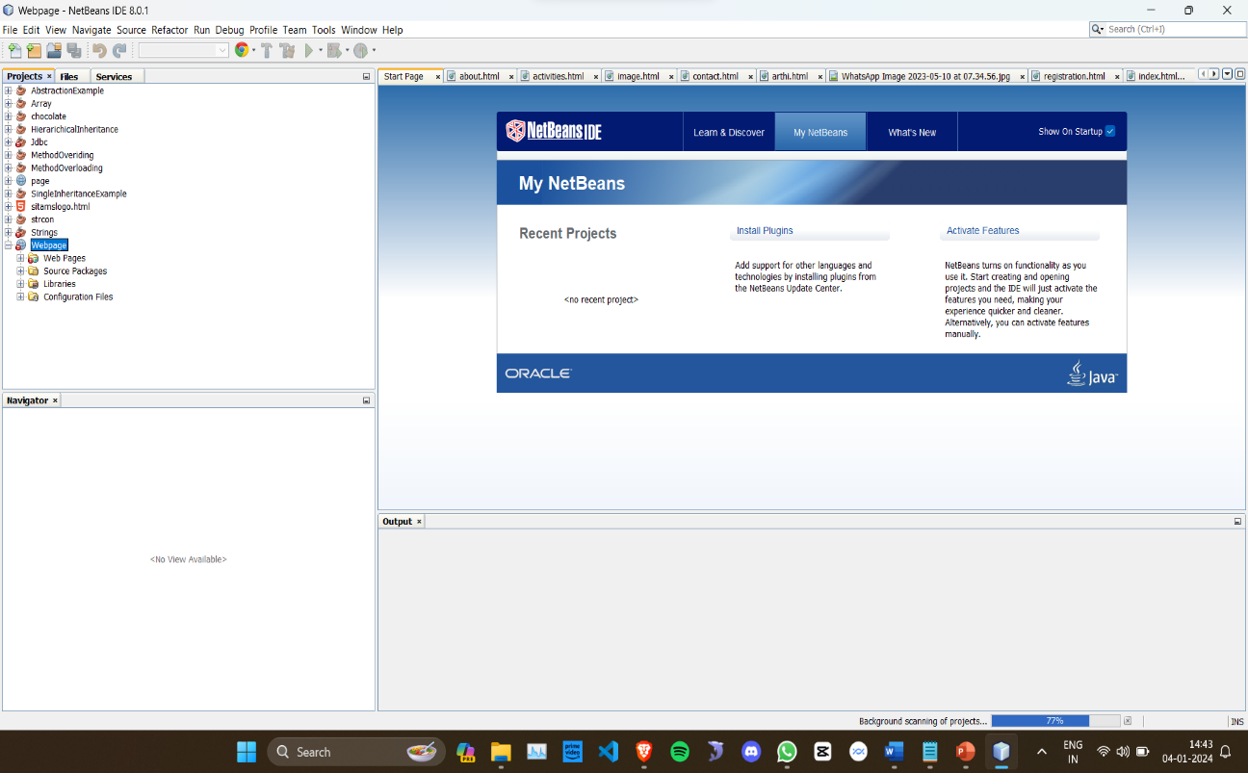

**Fig:2.1 Net beans**

**2.2 VS code**

Visual Studio Code (VS Code) is a free, open-source code editor developed by Microsoft. It has gained immense popularity among developers due to its versatility, powerful features, and extensive customization options. As of my last knowledge update in January 2022, the latest stable version was Visual Studio Code 1.63.1.

About Visual Studio Code:

Cross-Platform Compatibility VS Code is available for Windows, macOS, and Linux, providing a consistent development environment across different operating systems.Lightweight and Fast It is lightweight compared to full-fledged IDEs, yet it offers powerful features, ensuring a smooth and fast coding experience.

Rich Extension Ecosystem VS Code supports a vast array of extensions contributed by the community, enhancing functionality for various programming languages, tools, themes, and integrations with version control systems like Git.Integrated Terminal and Debugger It comes with an integrated terminal and debugger, allowing developers to run commands and debug code without switching to external applications.

Language Support Provides excellent support for multiple programming languages including JavaScript, Python, Java, C++, and more, with features like IntelliSense for code completion and syntax highlighting.

Git Integration Built-in Git version control features simplify source code management, allowing developers to commit, pull, push, and resolve merge conflicts directly within the editor.

Customizable Interface Users can customize the editor layout, themes, keyboard shortcuts, and install extensions tailored to their workflow, enhancing productivity.

Live Share Collaboration VS Code's Live Share extension enables real-time collaboration, allowing multiple developers to edit and debug code simultaneously from different locations.Task Automation It supports task automation through the integrated task runner, allowing developers to automate build tasks, test suites, and other repetitive actions.

Regular Updates The VS Code team regularly releases updates with new features, improvements, and bug fixes, ensuring a continuously evolving and optimized development environment.Visual Studio Code caters to a wide range of developers, from beginners to experienced professionals, providing an efficient, customizable, and feature-rich coding environment for various programming needs.

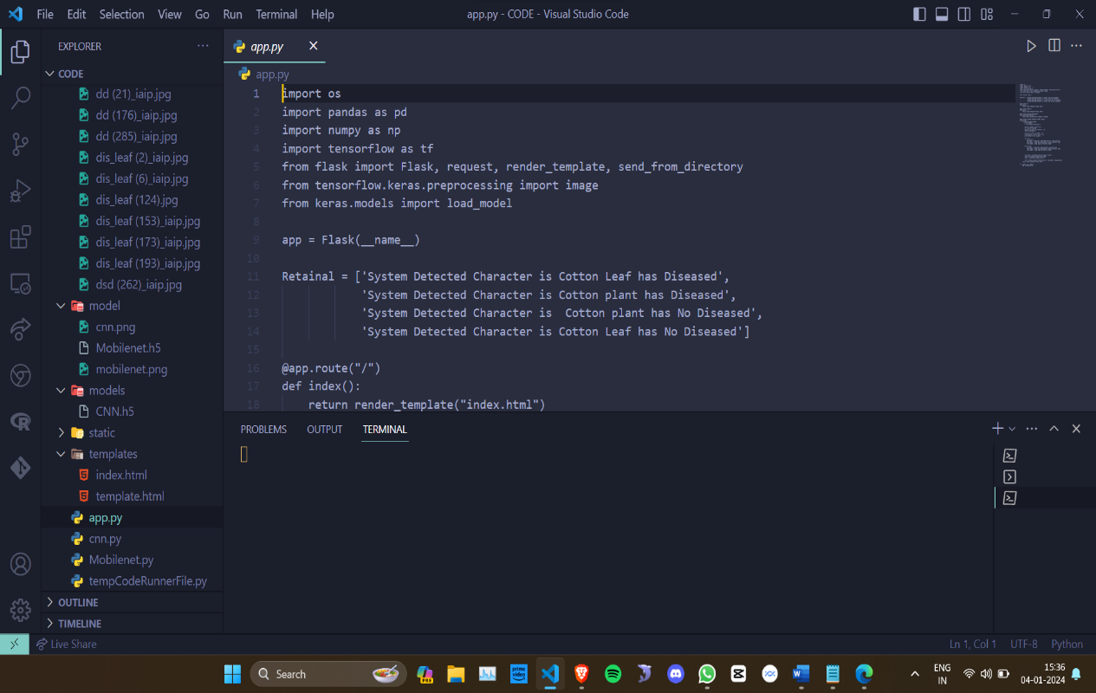

**Fig:2.2 VScode**

**2.3 SQL-yog**

[SQLyog is a powerful MySQL manager that helps database administrators manage MySQL and MariaDB in physical, virtual, and cloud environments](https://www.g2.com/products/sqlyog/reviews) . [SQLyog is available in two editions: the free Community edition and the paid, proprietary Ultimate edition](https://www.g2.com/products/sqlyog/reviews) [2](https://webyog.com/blog/sqlyog/what-are-the-benefits-of-sqlyogs-ultimate-versus-the-community-edition/). [Compared to the Community edition, the Ultimate edition offers valuable power tools and many additional features](https://www.g2.com/products/sqlyog/reviews)

SQLyog has several advantages over other MySQL managers. [It is more comfortable to work with many open queries, has better export options, and is better at auto-formatting queries](https://www.g2.com/products/sqlyog/reviews)  [SQLyog is also known for its autocomplete, query building, query profiler, and visual schema designer features, which help save time and increase productivity](https://www.g2.com/products/sqlyog/reviews) .[SQLyog’s work version is available on Windows, macOS, and Linux operating systems](https://www.g2.com/products/sqlyog/reviews) .

[SQLyog is a powerful GUI tool to manage MySQL and MariaDB servers and databases in physical, virtual, and cloud environments](https://www.g2.com/products/sqlyog/reviews) . [It provides extensive database administration and development support, including backup wizard and scheduling, query templates, code snippets, and abbreviations](https://www.g2.com/products/sqlyog/reviews) . [SQLyog is available in two editions: the free Community edition and the paid, proprietary Ultimate edition](https://www.g2.com/products/sqlyog/reviews) [2](https://webyog.com/blog/sqlyog/what-are-the-benefits-of-sqlyogs-ultimate-versus-the-community-edition/). [Compared to the Community edition, the Ultimate edition offers valuable power tools and many additional features](https://www.g2.com/products/sqlyog/reviews) .

SQLyog has several advantages over other MySQL managers. [It is more comfortable to work with many open queries, has better export options, and is better at auto-formatting queries](https://www.g2.com/products/sqlyog/reviews) . [SQLyog is also known for its autocomplete, query building, query profiler, and visual schema designer features, which help save time and increase productivity](https://www.g2.com/products/sqlyog/reviews) .

[SQLyog’s work version is available on Windows, macOS, and Linux operating systems](https://www.g2.com/products/sqlyog/reviews) . [SQLyog is a powerful GUI tool to manage MySQL and MariaDB servers and databases in physical, virtual, and cloud environments](https://www.g2.com/products/sqlyog/reviews) . [It provides extensive database administration and development support, including backup wizard and scheduling, query templates, code snippets, and abbreviations](https://www.g2.com/products/sqlyog/reviews) . [SQLyog is available in two editions: the free Community edition and the paid, proprietary Ultimate edition](https://www.g2.com/products/sqlyog/reviews) .



**Fig :2.3 SQLYOG**

**Chapter 3**

**Launguages used**

**3.1 Html**

HTML (HyperText Markup Language) is the standard markup language used to create and structure content on the World Wide Web. It forms the backbone of web pages by defining the structure and elements that make up the content displayed in web browsers. Here's a detailed overview of HTML:

Markup Language HTML uses a system of tags and attributes to describe the structure of content within a web page. Tags are used to encapsulate different types of content, such as headings, paragraphs, images, links, and more.

Semantic Structure HTML offers semantic elements that provide meaning to the content, aiding accessibility, SEO (Search Engine Optimization), and readability. Elements like <header>, <footer>, <nav>, <section>, <article>, and <aside> convey the structure and purpose of content.

Document Structure An HTML document typically includes a declaration, <html> element, containing <head> and <body> sections. The head section contains meta information, while the body section holds the visible content of the page.Elements and Attributes Elements are defined by tags enclosed in angle brackets (< >), and they may contain attributes providing additional information. Attributes modify the behavior or appearance of elements.

Text Formatting HTML supports various text formatting elements such as <h1> to <h6> for headings, <p> for paragraphs, <strong> and <em> for bold and italic text, <ul>/<ol> for lists, <br> for line breaks, and more.Hyperlinks and Anchors The <a> (anchor) element is used to create hyperlinks to other web pages or resources, allowing users to navigate across different parts of the web.

Images and Multimedia HTML provides the <img> tag to embed images and the <video> and <audio> tags to include multimedia content like videos and audio files directly into web pages.Forms and Input Elements HTML offers form elements like <form>, <input>, <select>,

Accessibility HTML includes features that support web accessibility, allowing developers to create accessible content using elements like alt attributes for images, label elements for form inputs, and ARIA attributes for enhanced accessibility.

Evolution and Standards HTML continues to evolve with new versions and specifications. HTML5, the latest version, introduced several new features like semantic elements, video/audio support, canvas for graphics, and APIs for offline web applications and geolocation.

HTML is fundamental to web development, serving as the building blocks for creating structured, accessible, and interactive web content, forming the core language that browsers interpret to display web pages.

**3.2 Css**

Cascading Style Sheets (CSS) is a cornerstone technology in web development, responsible for styling and presentation on web pages. It complements HTML by defining how content is displayed, formatted, and visually represented within web browsers. Here's a comprehensive overview of CSS:Styling Language CSS is a styling language that defines the appearance of HTML elements. It uses rules and selectors to target specific elements and apply styles to them.

Separation of Content and Presentation CSS promotes separation of concerns by separating the content (HTML) from its presentation (styling), allowing developers to maintain cleaner and more maintainable code.Syntax CSS comprises various rulesets, consisting of selectors that target HTML elements and declarations that define the style properties to be applied. Properties are set with values, affecting aspects like color, size, layout, typography, and more.

Selectors CSS provides a wide range of selectors including element selectors, class selectors (preceded by a period), ID selectors , attribute selectors, pseudo-classes, and pseudo-elements to target specific elements for styling.Cascading and Specificity CSS follows a cascading nature where multiple styles can be applied to an element based on the order of rules, origin of styles, and specificity of selectors. Specificity determines which styles take precedence.

Box Model CSS utilizes the box model, defining how elements are rendered in terms of content area, padding, border, and margin. This model governs layout and spacing of elements on the page.

Responsive Design CSS enables responsive web design by employing media queries, allowing developers to apply different styles based on factors like screen size, resolution, and device orientation, ensuring a consistent user experience across devices.

Flexbox and Grid Layout CSS offers powerful layout mechanisms like Flexbox and CSS Grid, enabling developers to create complex and responsive layouts with ease, facilitating better control over the arrangement of elements Transitions and Animations CSS supports transitions and animations, enabling the creation of interactive and engaging user experiences by adding movement and effects to elements without the need for JavaScript.

Vendor Prefixes and Compatibility CSS properties sometimes require vendor prefixes (-webkit-, -moz-, -ms-, -o-) for compatibility with different browsers, although modern browser support has reduced the necessity for many prefixes.CSS serves as an integral part of modern web development, allowing developers to transform static HTML content into visually appealing, responsive, and dynamic web experiences through the application of styles and layouts.

**3.3 Java script and core java**

Certainly! JavaScript and Java Core are two distinct aspects in the realm of programming languages. Let's delve into both:

**JavaScript**

JavaScript is a versatile and widely used programming language primarily utilized for web development. It's a client-side scripting language, meaning it runs within the user's web browser. Here's an in-depth look at JavaScript:

* **Dynamic and Versatile**: JavaScript is a dynamic language capable of manipulating web page content, handling events, creating interactive features, and enabling dynamic
* **Client-Side Scripting**: It executes on the client-side, allowing developers to create engaging and interactive web experiences by manipulating HTML, CSS, and the Document Object Model (DOM).
* **Functional Programming** :Java Script supports functional programming paradigms, allowing functions to be treated as first-class citizens, enabling higher-order functions, closures, and anonymous functions.
* **Event-Driven and Asynchronous**: It is event-driven, responding to user actions and interactions. JavaScript also supports asynchronous programming, facilitating non-blocking code execution using features like callbacks, promises, and async/await.
* **Cross-Platform Compatibility**: JavaScript is supported by all major browsers, making it a universal language for web development. Additionally, it's now used in backend development through platforms like Node.js.
* **Libraries and Frameworks**: Numerous libraries and frameworks like React, Angular, and Vue.js have emerged, enhancing JavaScript's capabilities and simplifying the development of complex web applications.
* **ECMAScript Standards**: JavaScript follows ECMAScript standards, with new features and enhancements introduced regularly. ES6 (ECMAScript 2015) and subsequent versions have brought significant improvements to the language.

**JavaCore:**

"JavaCore" isn't a specific term within the context of Java programming. However, Java is a robust and versatile programming language known for its platform independence and object-oriented principles. Here's an overview:

* **Platform Independence**:Java applications can run on any device or platform with the Java Virtual Machine (JVM), enabling "write once, run anywhere" (WORA) capabilities.
* **Object-Oriented Paradigm**: Java is purely object-oriented, emphasizing concepts like classes, objects, inheritance, encapsulation, and polymorphism.
* **Strongly Typed Language**: It's a statically typed language, requiring explicit declaration of variable types, promoting reliability and error checking during compile-time.
* **Rich Standard Library**: Java provides a comprehensive standard library with built-in functionalities for I/O, networking, collections, multithreading, and more, facilitating diverse application development.
* **Enterprise-level Applications**: Java is widely used in enterprise development, powering large-scale systems, web applications, mobile apps (Android), and backend services.
* **Community and Ecosystem**: Java boasts a vast community of developers and a rich ecosystem of frameworks (Spring, Hibernate), tools (Eclipse, IntelliJ IDEA), and libraries that enhance productivity and development efficiency.

Both JavaScript and Java have distinct roles and strengths in the programming landscape, catering to different aspects of software development, with JavaScript focusing primarily on web development and Java being used across a wide spectrum of applications.

**3.4 SQL**

Structured Query Language (SQL) is a standardized programming language designed for managing, querying, and manipulating data within relational database management systems (RDBMS). Here's a comprehensive overview of SQL:

Relational Databases: SQL is used to interact with relational databases, which store data in tables with defined relationships, enabling efficient data management and retrieval.Data Manipulation: SQL offers commands for CRUD operations: Create (INSERT), Read (SELECT), Update (UPDATE), and Delete (DELETE), allowing manipulation of data within tables.

Data Definition Language (DDL) SQL includes DDL statements (CREATE, ALTER, DROP) to define database schema, tables, views, indexes, and constraints, structuring the database.Data Querying (SELECT) The SELECT statement is fundamental in SQL, enabling the retrieval of data from tables based on specific criteria, conditions, joins, and sorting requirements.

Data Integrity and Constraints SQL allows the implementation of constraints like primary keys, foreign keys, unique constraints, and check constraints to ensure data integrity and maintain consistency.

Aggregate Functions SQL offers aggregate functions (SUM, AVG, COUNT, MIN, MAX) that perform calculations on groups of rows, providing statistical information and summary data.

Joins: SQL supports various types of joins (INNER JOIN, LEFT JOIN, RIGHT JOIN, FULL JOIN) to combine data from multiple tables based on common columns, enabling complex data retrieval.Transactions SQL supports transactions using commands like COMMIT, ROLLBACK, and SAVEPOINT, ensuring data consistency and integrity by treating operations as a single unit of work.Subqueries and Views SQL allows nesting queries (subqueries) within other queries, as well as creating views (virtual tables), enhancing modularity and reusability of code.

Security SQL includes features for user authentication, access control (GRANT, REVOKE), and data encryption, ensuring secure access and manipulation of sensitive information.Stored Procedures and Functions SQL enables the creation of stored procedures and functions, allowing developers to execute pre-defined logic on the database server, improving performance and reducing redundancy.

Standards and Versions: SQL follows ANSI/ISO standards, but various RDBMS implementations may differ in supported features and syntax based on versions (e.g., MySQL, PostgreSQL, Oracle, SQL Server).

**Chapter 4**

**WEB DEVELOPMENT**

**4.1 Idea of webpage**

A college club webpage serves as a central hub for information dissemination, community engagement, and fostering connections among club members and potential recruits. To effectively cater to its audience, a college club webpage should encompass key elements.

It needs clear and concise details about the club's mission, objectives, and activities, providing an overview that entices visitors to explore further. Including an events calendar, updated regularly with club meetings, social gatherings, and initiatives, helps members stay informed.

A gallery showcasing past events, achievements, and club highlights enhances engagement. Contact information, meeting schedules, and membership details should be easily accessible, encouraging potential members to join.

Integration of social media links fosters broader outreach and community interaction. Additionally, a blog or news section can offer insights, articles, or updates, further engaging visitors and portraying the club's vitality. Overall, a well-structured, informative, and interactive webpage can effectively represent a college club, promote its values, and attract enthusiastic members.

**The collage website contains**

* **Main login page**

The main page of a college website typically serves as the primary gateway and information hub for students, faculty, parents, and the wider community. Here are key components that might be included on the main page of a college website:

Welcome Message A warm and inviting welcome message or introduction to the college, showcasing its values, achievements, and ethos.

Navigation Menu An intuitive navigation menu providing quick access to various sections of the website, including academics, admissions, departments, student life, events, news, alumni, and more.Announcements or News A section featuring important announcements, upcoming events, recent news, and highlights within the college community.Featured Programs or Highlights Highlighted academic programs, initiatives, research, or achievements that showcase the college's strengths and offerings.

Admissions Information Information for prospective students, including details about admissions, application procedures, deadlines, and resources for exploring academic programs.Calendar of Events An interactive calendar displaying upcoming events, lectures, seminars, workshops, and important dates within the college community.

Student Resources Links or sections dedicated to student services, academic resources, campus facilities, housing, dining, career services, and student support programs.Faculty and Staff Directory Access to directories or profiles of faculty members, staff, and administrators, enabling communication and providing information about expertise and responsibilities.

Campus Virtual Tour or Gallery Visual representations of the campus through images, videos, or a virtual tour, offering insights into facilities, infrastructure, and campus life.Social Media Integration Links to official social media profiles to engage visitors and showcase the college's presence on various platforms.

Contact Information Clear and accessible contact details, including address, phone numbers, email addresses, and inquiry forms for inquiries or feedback.Emergency Alerts Information regarding emergency procedures, safety measures, and alerts for campus-wide announcements or updates.

The main page serves as a gateway to navigate the diverse offerings, achievements, and resources of the college, aiming to provide a comprehensive and user-friendly interface for all visitors.

* **Gallery showcase**

A gallery showcase on a college website encompasses a visual narrative reflecting the multifaceted aspects of campus life. Through a series of captivating images and multimedia content, it highlights the institution's diverse offerings, events, and facilities. This curated collection provides snapshots of campus facilities, including lecture halls, laboratories, sports complexes, and communal spaces, offering a glimpse into the infrastructure. It captures the vibrant tapestry of student life, portraying extracurricular activities, cultural events, student organizations, and community engagements. Furthermore, the gallery presents the scholarly pursuits of faculty members, showcasing their research endeavors, academic achievements, and contributions to knowledge. Graduation ceremonies, alumni success stories, and historical artifacts also find their place in this visual journey, underscoring the institution's legacy and the impact it leaves on its graduates. Through interactive elements and descriptive captions, the gallery serves as a window to the college's ethos, fostering engagement and offering prospective students and visitors an immersive experience into the vibrant ecosystem of the institution.

* **Staff details**

The staff details section of a college website provides comprehensive information about the faculty, administration, and support staff within the institution. This segment typically includes detailed profiles or directories featuring the names, positions, academic qualifications, areas of expertise, and contact information of faculty members, administrative staff, and department heads. Each staff member's profile may encompass their educational background, professional achievements, research interests, publications, and any honors or awards received. It often showcases their contributions to academia, industry experience, and involvement in academic committees or leadership roles within the college. Furthermore, this section may highlight staff members' affiliations with professional organizations, conferences, and community engagements, offering insights into their broader contributions beyond the institution. The staff details section serves as a resource for students, prospective students, parents, and other stakeholders to understand the expertise and qualifications of the faculty, enabling them to connect with specific individuals for academic guidance, research collaborations, or administrative queries. Additionally, it reflects the institution's commitment to transparency, professionalism, and academic excellence by providing an overview of the diverse talents and accomplishments of the dedicated individuals contributing to the college's academic community.

* **Registration page**

The registration process typically involves providing essential details such as name, roll number, and academic session, along with an avenue for students or participants to pose queries or concerns. Through a concise form or portal, individuals input their name, a unique identification number such as a roll number, and specify their academic session or term. Additionally, a section for queries or comments allows registrants to seek clarification, request information, or express any specific needs related to the registration process, courses, schedules, or other relevant aspects. This interactive feature not only streamlines the registration procedure but also fosters open communication, ensuring that participants can address any uncertainties or seek assistance while enrolling for courses or programs. Such a comprehensive registration system aims to facilitate a smooth and user-friendly experience, providing a platform for individuals to securely submit their details while also offering an avenue for inquiries, ultimately enhancing engagement and satisfaction among registrants.

* **Contact page**

The contact page on a website serves as a centralized platform enabling visitors to connect with the institution or organization efficiently. It typically includes essential contact information such as address, phone numbers, email addresses, and a contact form for inquiries or feedback. This page provides a user-friendly interface for individuals to reach out with queries, requests for information, or any concerns they might have. It ensures accessibility and convenience by offering multiple communication channels, allowing visitors to choose their preferred method of contact. Moreover, the inclusion of maps or directions enhances accessibility, guiding individuals to the institution's physical location. The contact page plays a pivotal role in fostering effective communication between the organization and its audience, promoting engagement, addressing inquiries promptly, and ensuring a positive user experience.

* **HOD details**

The Head of Department (HOD) details section on a college or institution's website presents comprehensive information about the departmental head, offering insights into their professional background, responsibilities, and contact information. It typically includes the name, academic qualifications, areas of expertise, and professional experience of the HOD. Additionally, this segment might outline the HOD's role in academic administration, leadership within the department, involvement in curriculum development, research initiatives, and their contributions to the institution's academic growth. Contact details such as email addresses, phone numbers, and office location enable students, faculty, and external stakeholders to reach out to the HOD for academic guidance, administrative queries, or collaborations. This section serves as a valuable resource for individuals seeking to understand the leadership and expertise guiding a specific department, fostering transparency, and facilitating effective communication within the academic community

* **About the club**

The Club Details section on a college or organization's website provides an overview of the various clubs, societies, or student organizations available, offering insights into their missions, activities, and contact information. This segment typically includes a list of clubs, each accompanied by a brief description highlighting the club's purpose, objectives, and focus areas. It may also feature details regarding club leadership, faculty advisors, meeting schedules, upcoming events, and membership criteria. Additionally, the section might incorporate images, videos, or links showcasing the club's past activities, achievements, or notable events. Contact information, including email addresses or social media links, allows interested individuals to reach out, inquire about membership, or get involved in specific club activities. The Club Details section serves as a platform for students to explore diverse interests, discover opportunities for engagement, and connect with like-minded peers, contributing to a vibrant and inclusive campus community**.**

* **Social media link**

Social media links on a website refer to clickable icons or hyperlinks that redirect users to the institution's official profiles on various social networking platforms. These links typically include icons representing platforms such as Facebook, Twitter, Instagram, LinkedIn, YouTube, and others. By clicking on these icons, visitors are directed to the respective social media profiles where the institution actively engages with its audience. These profiles often showcase updates, events, news, photos, videos, and other relevant content, allowing users to stay connected and engaged with the institution's activities beyond the website. Integrating social media links enhances connectivity, encourages interaction, and broadens the institution's reach by leveraging the popularity and accessibility of social networking platforms. Additionally, it serves as a dynamic channel for disseminating information, fostering community engagement, and maintaining an active online presence within the broader digital landscape.

**Chapter 5**

**RESULTS AND OUTPUTS**

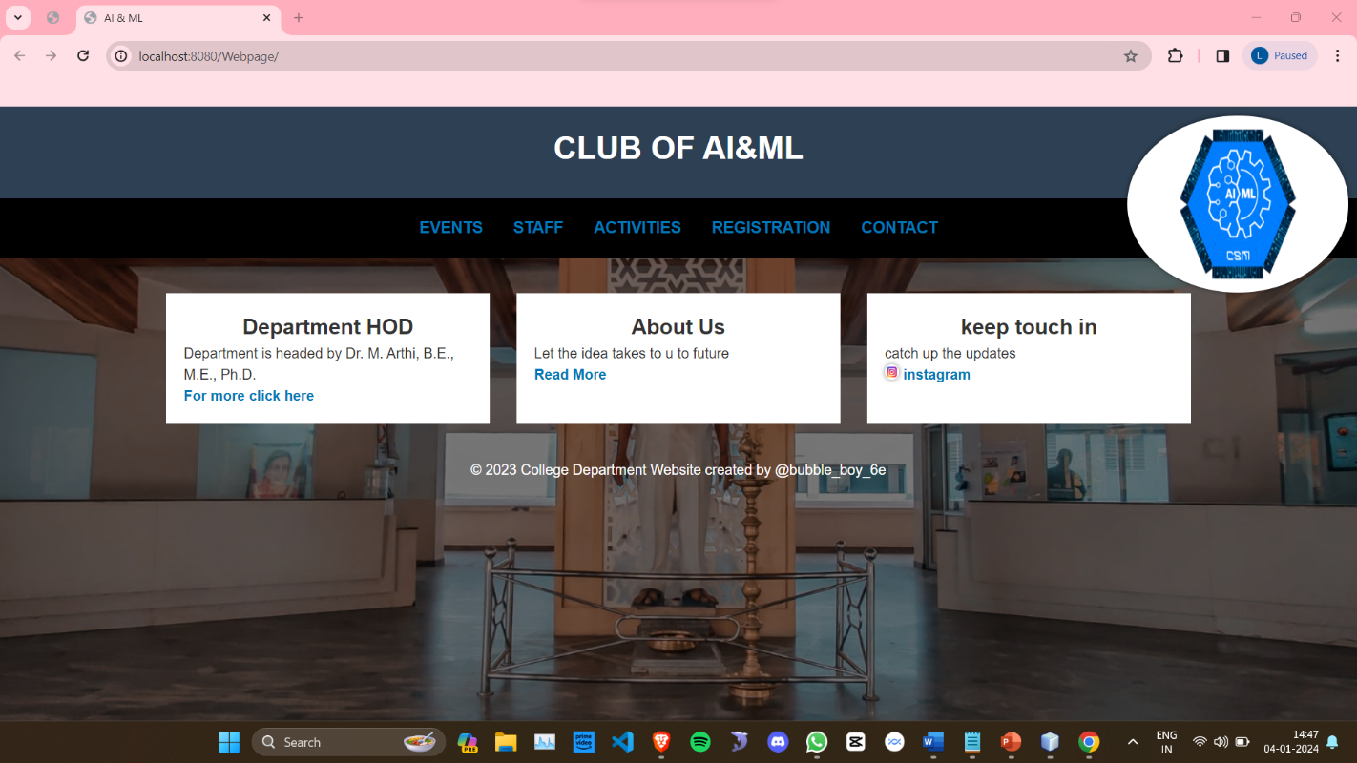

**Fig 5.1: Main page**

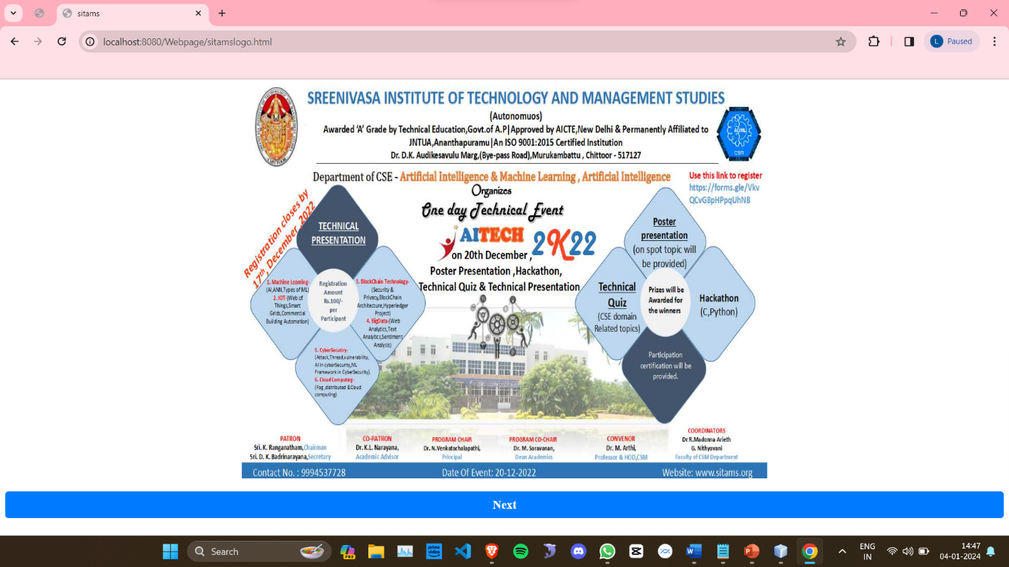

**Fig 5.2 :Showcase**

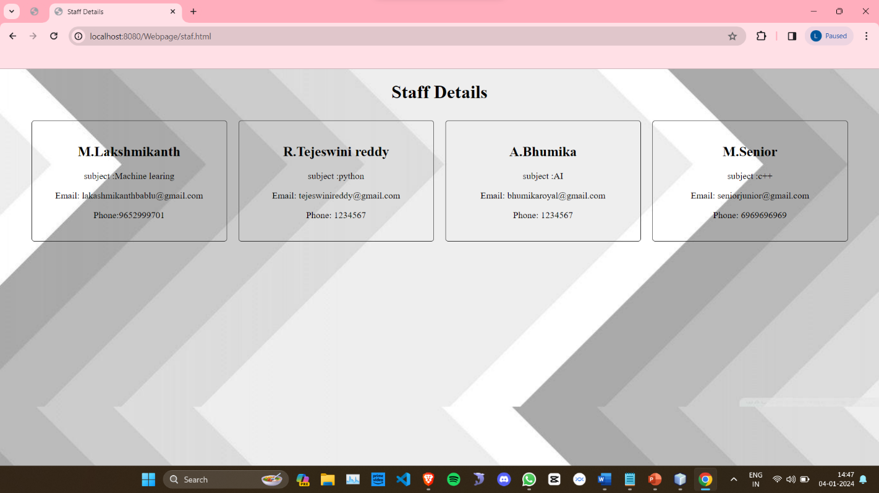

**Fig 5.3:Staff details**

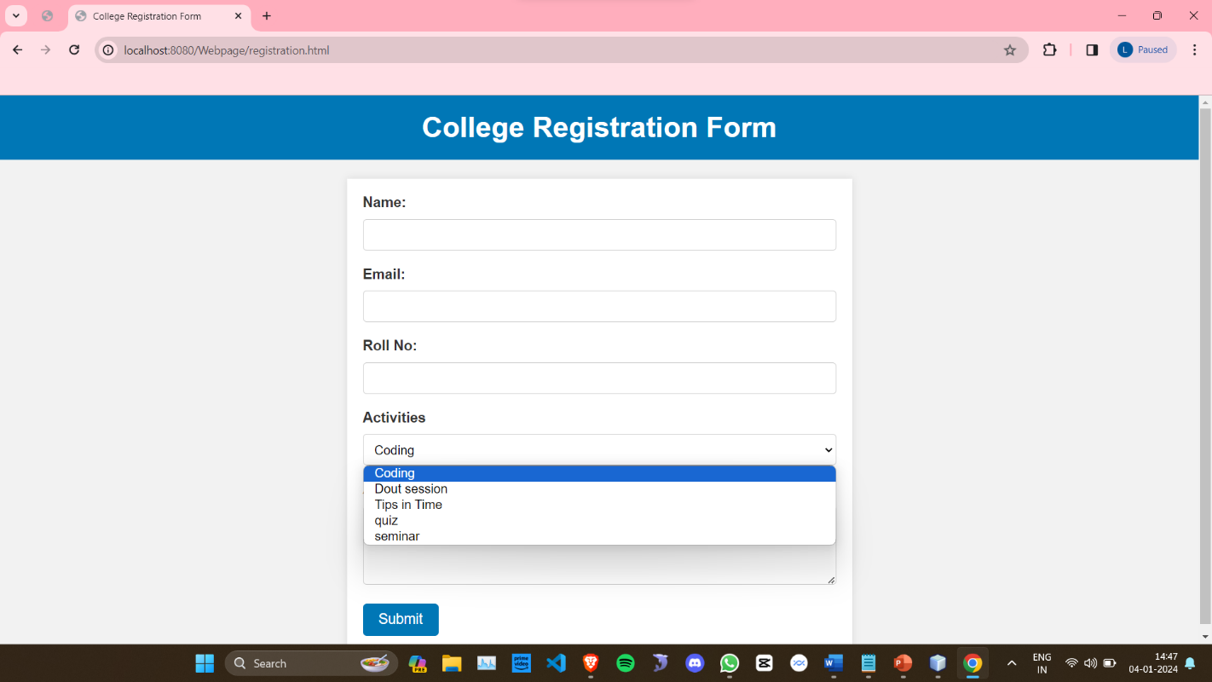

**Fig 5.4:Registration page**

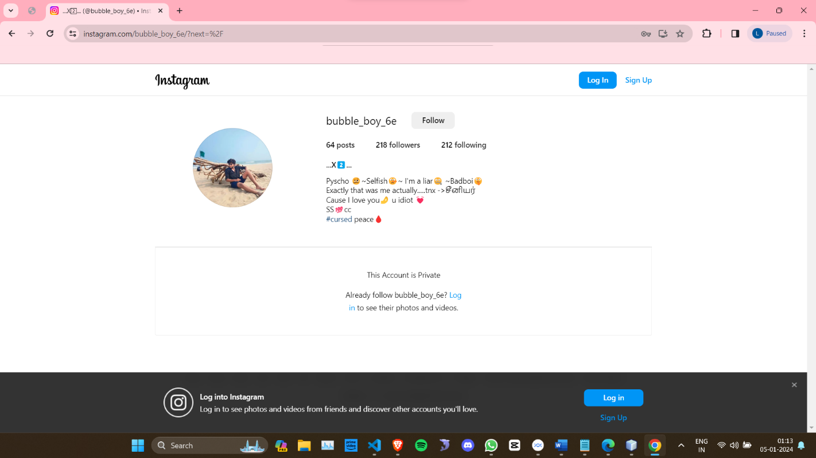

**Fig 5.5:Social media link**

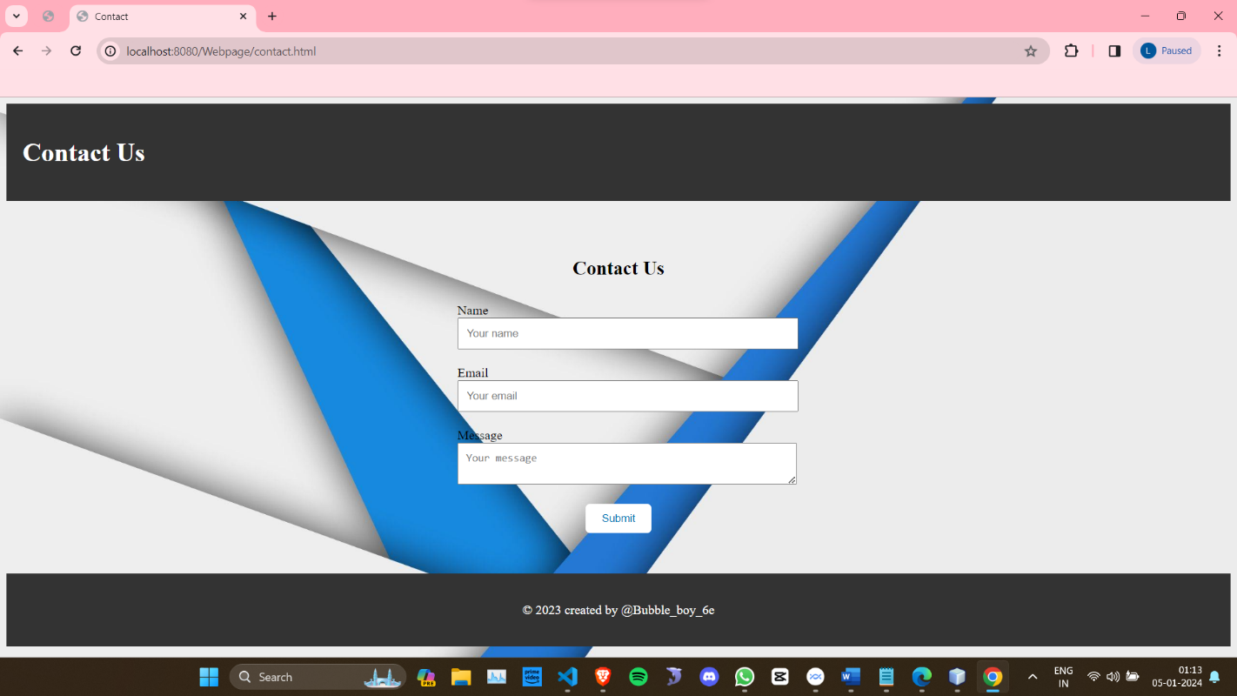

**Fig 5.6:Contact page**

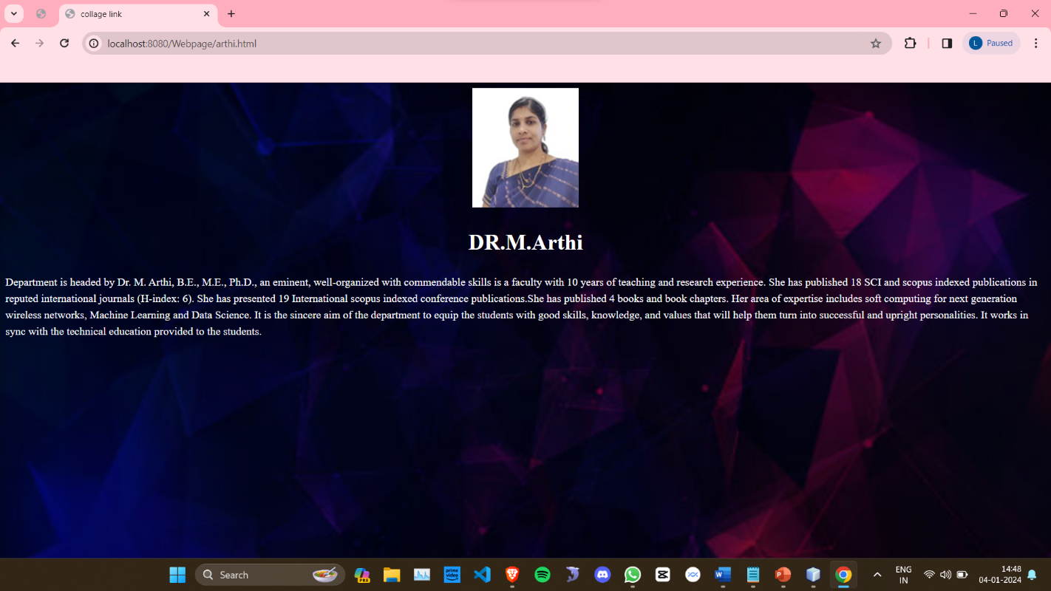

**Fig 5.7:HOD detials**

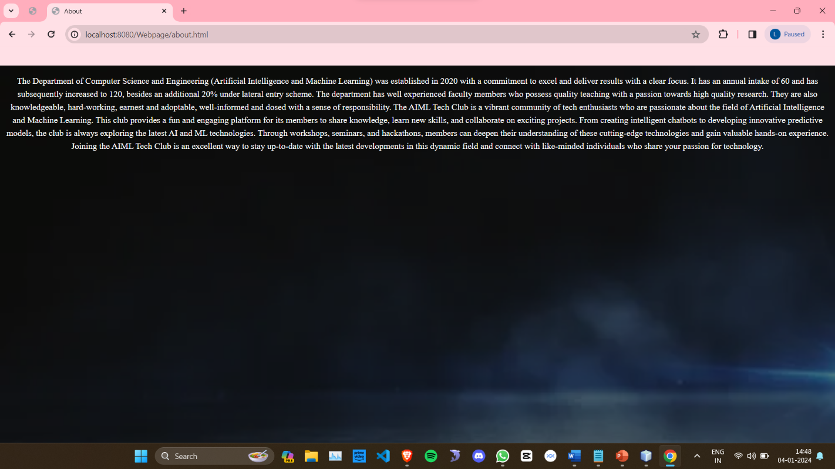

**Fig 5.8:About the club**

**CONCLUSION AND FUTURE ENHANCEMENT**

A meticulously designed and organized college club webpage stands as a cornerstone for effective communication, active engagement, and fostering a sense of community within the campus milieu. It serves as more than just an online presence; it's a dynamic platform that encapsulates the club's essence, guiding principles, and its pivotal role within the college ecosystem. By incorporating indispensable components such as succinct mission statements, comprehensive membership details, easily accessible leadership contacts, and interactive functionalities, the webpage transcends its role as a mere informational hub. Instead, it transforms into a vibrant space that actively nurtures connections among current members while enticing potential recruits through its inviting and inclusive ambiance.

The whole project done with the programming language used HTML,CSS,JAVACORE,JAVASCRIPT,JDBC,SQL using the software like Net beans,Yog sql,vscode

The webpage's emphasis on inclusivity, perpetually updated content, visually compelling design, and a plethora of opportunities for involvement doesn't merely showcase the club's activities—it amplifies its impact. It serves as an inviting doorway, welcoming individuals to explore, connect, and actively participate in the club's initiatives, fostering a sense of belonging and camaraderie among its members. Its regular updates and captivating visuals not only capture attention but also convey the club's dynamic nature, instigating curiosity and enthusiasm among visitors. Moreover, by providing diverse avenues for involvement, be it through volunteering, leadership roles, or collaborative events, the webpage encourages active participation, empowering individuals to contribute meaningfully and shape the club's trajectory.

**REFRENCES**

1. MDN Web Docs (Mozilla Developer Network) - A comprehensive resource for web developers, offering extensive documentation, tutorials, and references on HTML, CSS, JavaScript, and web APIs. Website: [MDN Web Docs](https://developer.mozilla.org/).

2. **W3Schools** - Provides tutorials, examples, and references on HTML, CSS, JavaScript, and various web development technologies in an easily understandable format. Website: [W3Schools](https://www.w3schools.com/).

3. **CSS-Tricks** - A web design community that offers tutorials, articles, code snippets, and resources focusing on CSS, JavaScript, and front-end development. Website: [CSS-Tricks](https://css-tricks.com/).

4. **Smashing Magazine** - Publishes articles, tutorials, and resources on web design, front-end development, UX/UI, and various web-related topics. Website: [Smashing Magazine](https://www.smashingmagazine.com/).

5. **Stack Overflow** - A popular Q&A platform where developers ask questions, share knowledge, and find solutions to coding and development queries. Website: [Stack Overflow](https://stackoverflow.com/).

6. **GitHub** - A code repository hosting service that offers access to a vast number of open-source projects, libraries, frameworks, and resources for web development. Website: [GitHub](https://github.com/).

7. **Codecademy** - An interactive learning platform offering coding courses on HTML, CSS, JavaScript, and other programming languages. Website: [Codecademy](https://www.codecademy.com/).

8. **FreeCodeCamp** - Provides free online courses, tutorials, and coding challenges covering HTML, CSS, JavaScript, and other aspects of web development. Website: [FreeCodeCamp](https://www.freecodecamp.org/).

9. **Dev.to** - A community-based platform where developers share articles, tips, tutorials, and insights on web development and programming. Website: [Dev.to](https://dev.to/).

10. **Mozilla Developer Network (MDN) Web Docs** - Offers in-depth documentation, guides, and tutorials on web technologies including HTML, CSS, JavaScript, and more. Website: [MDN Web Docs](https://developer.mozilla.org/).

These platforms provide a wealth of information, tutorials, and community support for individuals looking to learn or enhance their skills in web development.

APPENDEX

!DOCTYPE html>

<html lang="en">

<head>

<meta charset="UTF-8">

<meta name="viewport" content="width=device-width, initial-scale=1.0">

<title>AI &amp; ML</title>

<style>

/* Reset styles */

* {

margin: 0;

padding: 0;

box-sizing: border-box;

}

/* Global styles */

body {

font-family: Arial, sans-serif;

background-color: #f2f2f2;

color: #333;

line-height: 1.5;

background-image:linear-gradient(rgba(0,0,0,0.5),rgba(0,0,0,0.5)), url("WhatsApp Image 2023-05-11 at 22.24.36.jpg");

background-size: cover;

}

h1, h2, h3 {

font-weight: bold;

text-align: center;

}

a {

color: #0077b6;

text-decoration: none;

font-weight: bold;

}

a:hover {

color: #004f77;

}

img {

max-width: 100%;

height: auto;

border-radius: 50%;

box-shadow: 0 0 5px rgba(0,0,0,0.5);

}

/* Header styles */

header {

background-color: #2E4053;

color: #fff;

padding: 20px;

}

h1 {

font-size: 36px;

margin-bottom: 10px;

}

/* Navigation styles */

nav {

background-color: black;

padding: 10px;

text-align: center;

margin-bottom: 20px;

}

nav a {

display: inline-block;

padding: 10px;

margin: 0 5px;

font-size: 18px;

border-radius: 5px;

transition: background-color 0.3s ease;

}

nav a:hover {

background-color: #0077b6;

color: #fff;

}

main {

max-width: 1200px;

margin: 0 auto;

padding: 20px;

display: flex;

flex-wrap: wrap;

justify-content: space-between;

}

article {

background-color: #fff;

padding: 20px;

margin-bottom: 20px;

flex-basis: calc(33.33% - 20px);

}

article h2 {

margin-top: 0;

}

article p {

margin: 0;

line-height: 1.5;

}

footer {

color: #fff;

text-align: center;

}

.image-container {

position: absolute;

top: 0;

right: 0;

padding: 10px;

box-sizing: border-box;

z-index: 999;

}

.image-container img {

width: 250px;

height: 200px;

border-radius: 100%;

box-shadow: 0 0 5px rgba(0,0,0,0.5);

}

</style>

<body>

<header>

<h1>CLUB OF AI&ML</h1>

</header>

<nav>

<a href="sitamslogo.html">EVENTS</a>

<a href="staf.html">STAFF</a>

<a href="activities.html">ACTIVITIES</a>

<a href="registration.html">REGISTRATION</a>

<a href="contact.html">CONTACT</a>

</nav>

<div class="image-container">

<img src="Aiml.jpg" alt="profile image">

</div>

<main>

<article>

<h2>Department HOD</h2>

<p>Department is headed by Dr. M. Arthi, B.E., M.E., Ph.D.</p>

<a href="arthi.html">For more click here</a>

</article>

<article aling="center">

<h2>About Us</h2>

<p>Let the idea takes to u to future </p>

<a href="about.html">Read More</a>

</article>

<article>

<h2>keep touch in </h2>

<p>catch up the updates</p>

<img src="" alt="instagram" width="5%">

<a href="https://www.instagram.com/bubble_boy_6e/?next=%2F">instagram</a>

</article>

</main>

<footer>

<p>&copy; 2023 College Department Website created by @bubble_boy_6e </p>

</footer>

</body>

</html>

Evaluation Rubrics for Project work:

|  |  |  |  |
| --- | --- | --- | --- |
| **Rubric (CO)** | **Excellent (Wt = 3)** | **Good (Wt = 2)** | **Fair (Wt = 1)** |
| ***Selection of Topic (CO1)*** | Select a latest topic through complete knowledge of facts and concepts. | Select a topic through partial knowledge of facts and concepts. | Select a topic through improper knowledge of facts and concepts. |
| ***Analysis and Synthesis (CO2)*** | Thorough comprehension  through analysis/ synthesis. | Reasonable comprehension  through analysis/ synthesis. | Improper comprehension  through analysis/ synthesis. |
| ***Problem Solving (CO3)*** | Thorough comprehension about what is proposed in the literature papers. | Reasonable comprehension about what is proposed in the literature papers. | Improper comprehension about what is proposed in the literature. |
| ***Literature Survey (CO4)*** | Extensive literature survey with standard references. | Considerable  literature survey with standard references. | Incomplete literature survey with substandard references. |
| ***Usage of Techniques & Tools (CO5)*** | Clearly identified and has complete knowledge of  techniques & tools used in the project work. | Identified and has sufficient knowledge of techniques & tools used in the project work. | Identified and has inadequate knowledge of techniques & tools used in project work. |
| ***Project work impact on Society (CO6)*** | Conclusion of project work has strong impact on society. | Conclusion of project work has considerable impact on society. | Conclusion of project work has feeble impact on society. |
| ***Project work impact on Environment (CO7)*** | Conclusion of project work has strong impact on  Environment. | Conclusion of project work has considerable impact on  environment. | Conclusion of project work has feeble impact on  environment. |

Evaluation Rubrics for Project work:

|  |  |  |  |
| --- | --- | --- | --- |
| **Rubric (CO)** | **Excellent (Wt = 3)** | **Good (Wt = 2)** | **Fair (Wt = 1)** |
| ***Selection of Topic (CO1)*** | Select a latest topic through complete knowledge of facts and concepts. | Select a topic through partial knowledge of facts and concepts. | Select a topic through improper knowledge of facts and concepts. |
| ***Analysis and Synthesis (CO2)*** | Thorough comprehension  through analysis/ synthesis. | Reasonable comprehension  through analysis/ synthesis. | Improper comprehension  through analysis/ synthesis. |
| ***Problem Solving (CO3)*** | Thorough comprehension about what is proposed in the literature papers. | Reasonable comprehension about what is proposed in the literature papers. | Improper comprehension about what is proposed in the literature. |
| ***Literature Survey (CO4)*** | Extensive literature survey with standard references. | Considerable  literature survey with standard references. | Incomplete literature survey with substandard references. |
| ***Usage of Techniques & Tools (CO5)*** | Clearly identified and has complete knowledge of  techniques & tools used in the project work. | Identified and has sufficient knowledge of techniques & tools used in the project work. | Identified and has inadequate knowledge of techniques & tools used in project work. |
| ***Project work impact on Society (CO6)*** | Conclusion of project work has strong impact on society. | Conclusion of project work has considerable impact on society. | Conclusion of project work has feeble impact on society. |
| ***Project work impact on Environment (CO7)*** | Conclusion of project work has strong impact on  Environment. | Conclusion of project work has considerable impact on  environment. | Conclusion of project work has feeble impact on  environment. |